
STUDENT CASE STUDY EXECUTION REPORT
Department | FED
Subject | DSA -2
Academic year | I – III Semester(2025-26)
Faculty Name | V. GopiKrishna
Student Name | K. Sriram
Roll Number | 2520040072
Branch | ECE
Course Outcome | 2

Case Study Topic : EventSphere Event Schedule Range Query using B+ Tree
EventSphere is a smart event planning and management platform that handles event scheduling, venue reservations, participant registrations, ticketing, and analytics.
Each event is scheduled on a particular date and stored in the system.
Users frequently search events between selected dates.
To improve efficient searching across a range of dates, EventSphere uses a B+ Tree structure.
For one event week, the following events are stored:
Date | Event
06/06/2026 | Music Fest
08/06/2026 | Workshop
12/06/2026 | Tech Talk
15/06/2026 | Hackathon
20/06/2026 | Project Expo
22/06/2026 | Seminar
All dates are inserted into the schedule index.
A user searches for events between:

07/06/2026 to 18/06/2026

The system should return matching events efficiently.

Question
Using the EventSphere Event Schedule scenario above:
- Construct the B+ Tree using event dates
- Store records in leaf nodes
- Link leaf nodes sequentially
- Perform range query
- Calculate search time
- Explain why B+ Tree is suitable

Analysis & Implementation

1.1 Event insertion
Inserted dates:

06/06/2026
08/06/2026
12/06/2026
15/06/2026
20/06/2026
22/06/2026

B+ Tree insertion:
- Internal nodes store date references
- Leaf nodes store actual event data
- Leaf nodes linked sequentially
Structure:

[12/06/2026]
/ \
[06/06][08/06] [15/06][20/06][22/06]

Leaf links:

06/06 → 08/06 → 12/06 → 15/06 → 20/06 → 22/06

1.2 Range query
Search range:

07/06/2026 to 18/06/2026

Matching events:

08/06/2026 - Workshop
12/06/2026 - Tech Talk
15/06/2026 - Hackathon

1.3 Time complexity
Operation | Complexity
Insert | O(log n)
Search | O(log n)
Range Query | O(log n + k)

1.4 SLA calculation
Given:
- Pointer hop = 200 ns
- Budget = 5 ms
Assume:
Tree height = 2
Worst-case:

2 × 200 ns = 400 ns

Convert:

400 ns = 0.0004 ms

Percentage:

(0.0004 / 5) × 100 = 0.008%

System satisfies SLA.

1.5 Why B+ Tree is suitable
Advantages:
- Fast search
- Efficient range query
- Sorted records
- Leaf linking improves sequential access
- Handles large event databases
For EventSphere:
- event dates stay ordered
- users search by date range quickly
- efficient schedule management

2. Final reasoning
For EventSphere:
- Dates inserted efficiently
- Records stay sorted
- Range query fast
- Search predictable
- Suitable for event schedule indexing
Code:
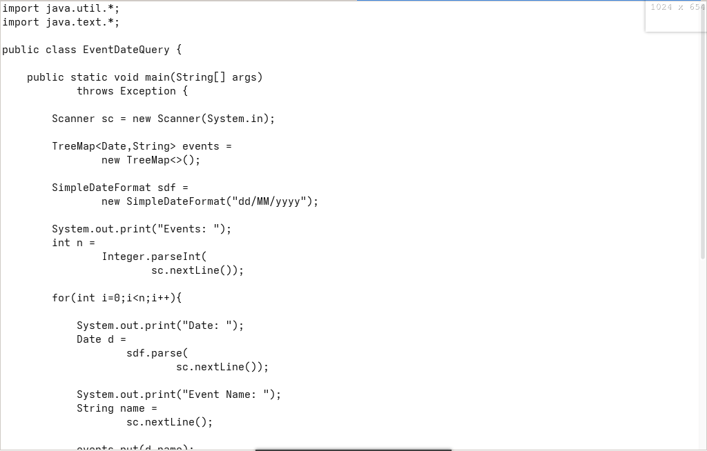

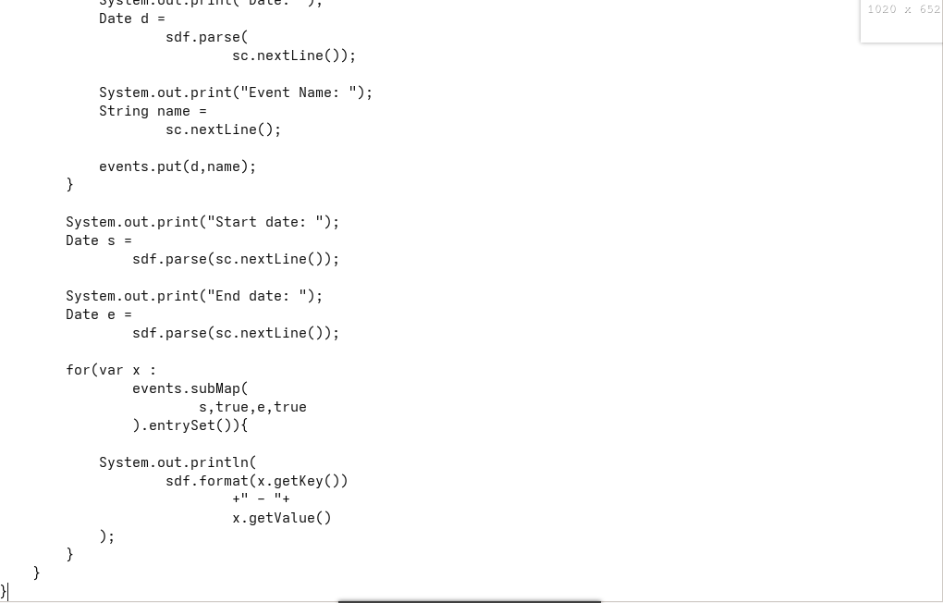
Output:

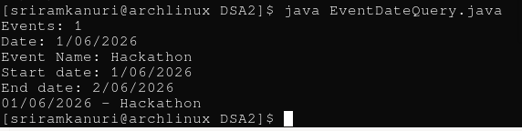

GitHub Link: https://github.com/kanurisriram/EventSphere

Student Signature | Faculty Signature
____________________ | ___________________

